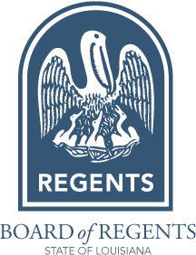
Program Improvement Action Plan
Due January 15, 2025

This form is for programs identified by the Board of Regents as having problematic enrollment and completion numbers during the 2024 Academic Plan and Low Completer review processes. Programs required to submit an Action Plan are listed either in Academic Plan Attachment B: Progress Reports from the September 2024 Regents meeting agenda materials or in the Low Completer list sent to Chief Academic Officers by email in October 2024. Please contact Regents Academic Affairs staff with questions.
A separate form must be completed for each program. Plans must be substantive, specific, actionable, and based on target goals with dates. Plans should identify the program’s primary problems with planned solutions and should address how the program will ensure it is meeting the needs of students and the state.
If the program will be terminated, please only answer question 1. For all other programs, please answer questions 2-4.
Institution Name: | Designation (flagship, statewide, regional, HBCU, 2-year):
College/School/Division: | Academic Department:
Degree Designation and Name (i.e. PhD Phone Operator): |  |  | CIP Code:
Program Primary Contact (Name and Title): |  | Primary Contact Email Address:
Institution Primary Academic Affairs Contact (Name and Title) |  | A.A. Contact Email Address:

- TERMINATION REQUEST: If this program will be terminated, please indicate the termination date and briefly describe the reason for termination and the teach-out plan. (Please note that graduates can be entered into SSPS for terminated programs during the teach-out period.)

- Describe the primary reasons the program is not currently meeting completion and/or enrollment targets.

- Identify specific and detailed actions planned to address each of the issues described above.

- Provide a timeline for program improvement. Identify milestones and/or target metrics toward achieving successful program improvement, and enrollment and completion growth.

